**A. Notes on Data Extraction as It Appears in Current Data Library**

1. The main paper in this folder is Crooks (2014) "COASTAL BLUE CARBON OPPORTUNITY ASSESSMENT FOR THE SNOHOMISH ESTUARY THE CLIMATE BENEFITS OF ESTUARY RESTORATION"”

2. The sites in this study were coded in the data library as follows:

|  |  |  |
| --- | --- | --- |
| **Library** | **Paper** | **Notes** |
| site1 | Site1 Quilceda (QM) |  |
| site2 | Site2 Heron Point (HP) |  |
| site3 | Site3 Otter Island (OI) |  |
| site4 | Site4 North Ebey (NE) |  |
| site5 | Site5 Spencer Island (SP) |  |
| site6 | Site6 Marysville Mitigation (MA) |  |
| site7 | Site7 Smith Island City - South (SS) |  |
| site8 | Site8 Union Slough (US) |  |
| Site9 | Site9 Qwuloolt (QW) |  |
| Site10 | Site10 Smith Is. County (SN) |  |
| Site11 | Site11 WDFW Wetland (WW) |  |
| Site12 | Site12 WDFW Forested (WF) |  |

The photos and dominant species of the sites were below:

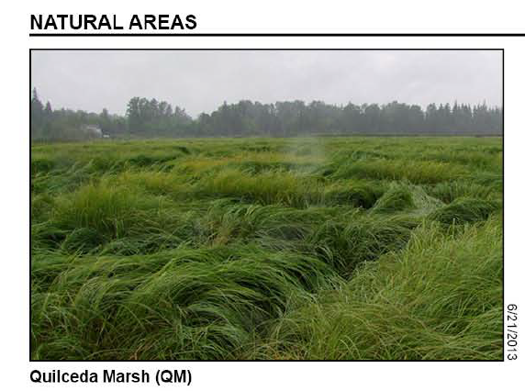

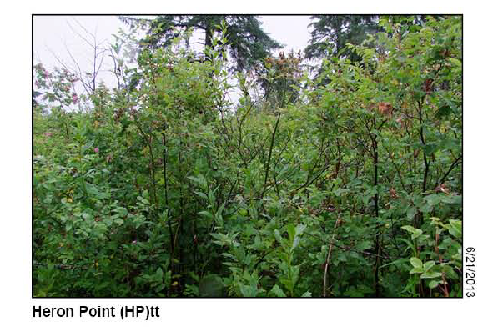

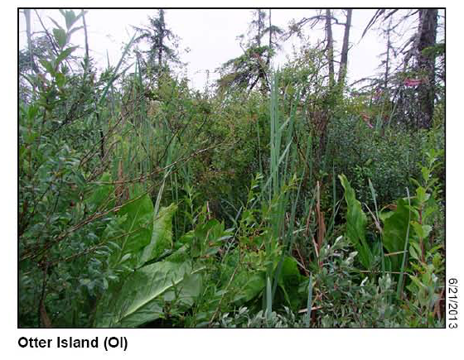

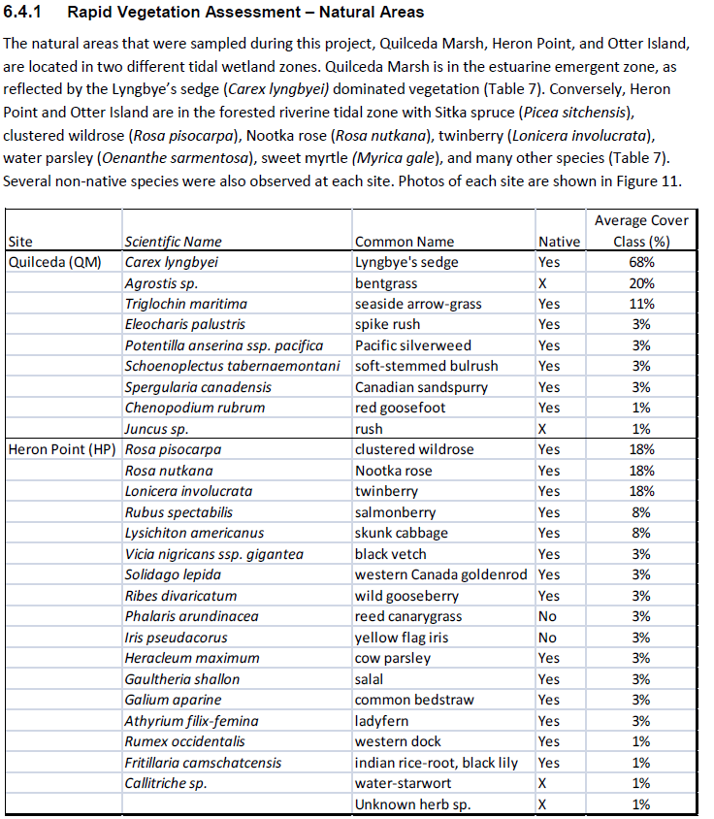

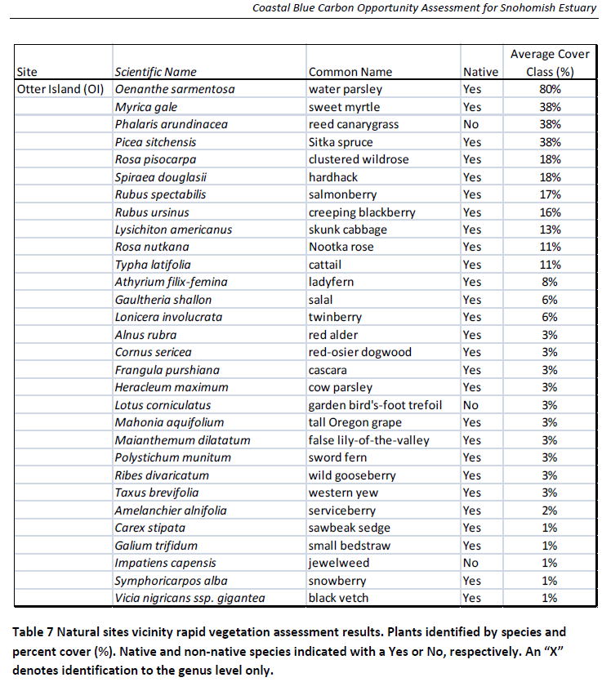

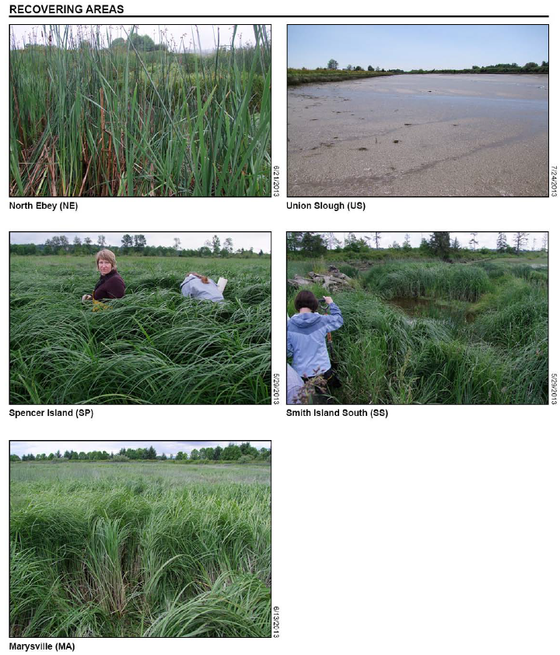

**B. History of Calculation Refinements**

1. Meng found there are 2 variables in the table 10 (page 43) for soil carbon pool. 1. “Total carbon mass in top 30 cm (kg C m-2)” and 2. “Average carbon density in top 30 cm (g C cm-3)”. Data Blanca reported are from “Average carbon density in top 30 cm (g C cm-3)”.

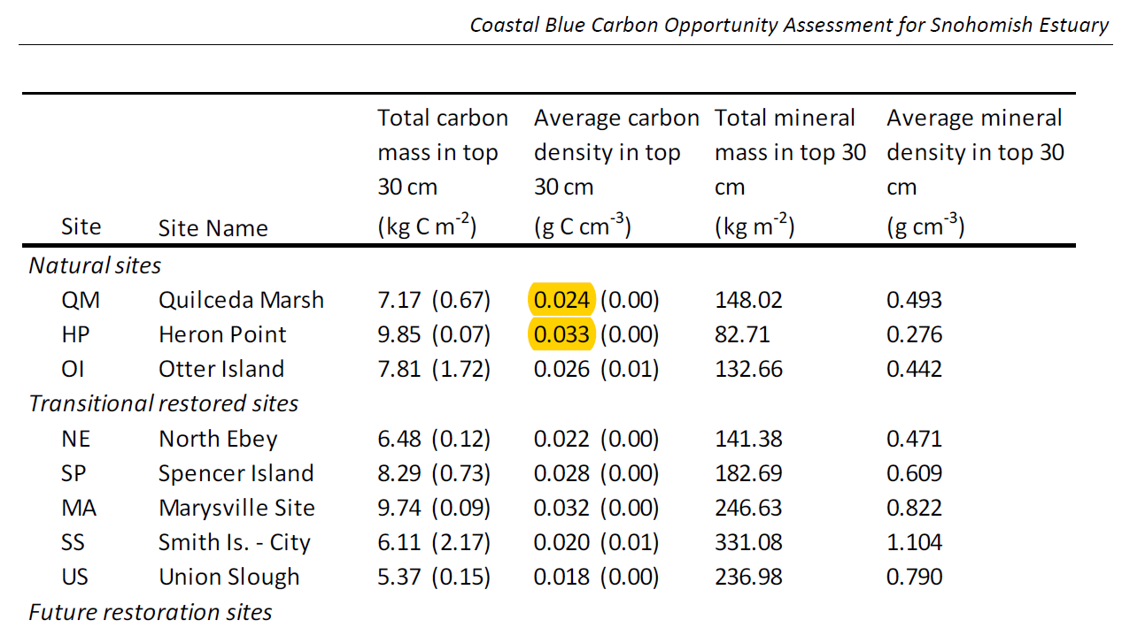

2. Soil C rate data was from Table 11 (page 43)

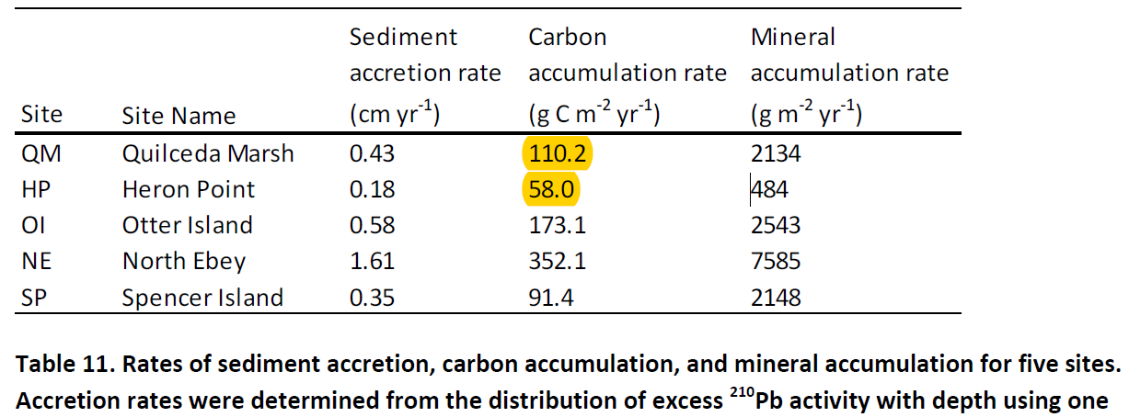

3. Meng also found that the Longitude should be “-122.02” but not “122.02” on Blanca’s datasheet.